BSI C5 Compliance for Log360
Tagline: Establish cloud security assurance under the BSI Cloud Computing Compliance using Log360.

Overview
The BSI C5 (Cloud Computing Compliance Criteria Catalogue) Compliance extension for Log360 helps German and European cloud service providers and their customers validate security controls against BSI's cloud assurance standard.
Log360 collects and correlates logs from cloud infrastructure, identity systems, applications, and network devices, providing continuous visibility into security events relevant to BSI C5 control domains including identity management, logging, and incident response. Compliance teams can monitor control effectiveness, detect deviations, and generate audit-ready evidence for BSI C5 attestations.

Key Features
- Generate audit reports mapped to BSI C5 control domains covering security event logging, identity and access management, and incident detection.
- Monitor cloud infrastructure access events, configuration changes, and privileged operations in real time across AWS, Azure, and Google Cloud environments.
- Leverage preconfigured threat intelligence and correlation rules to detect attacks targeting cloud workloads and sensitive data stores.
- Export C5-aligned compliance evidence in PDF and CSV formats for BSI attestation audits and customer transparency reports.

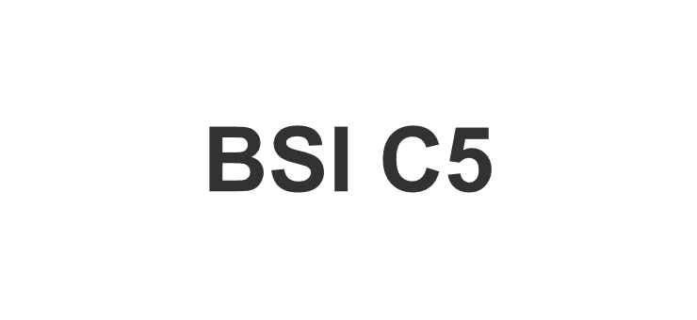

Screenshots
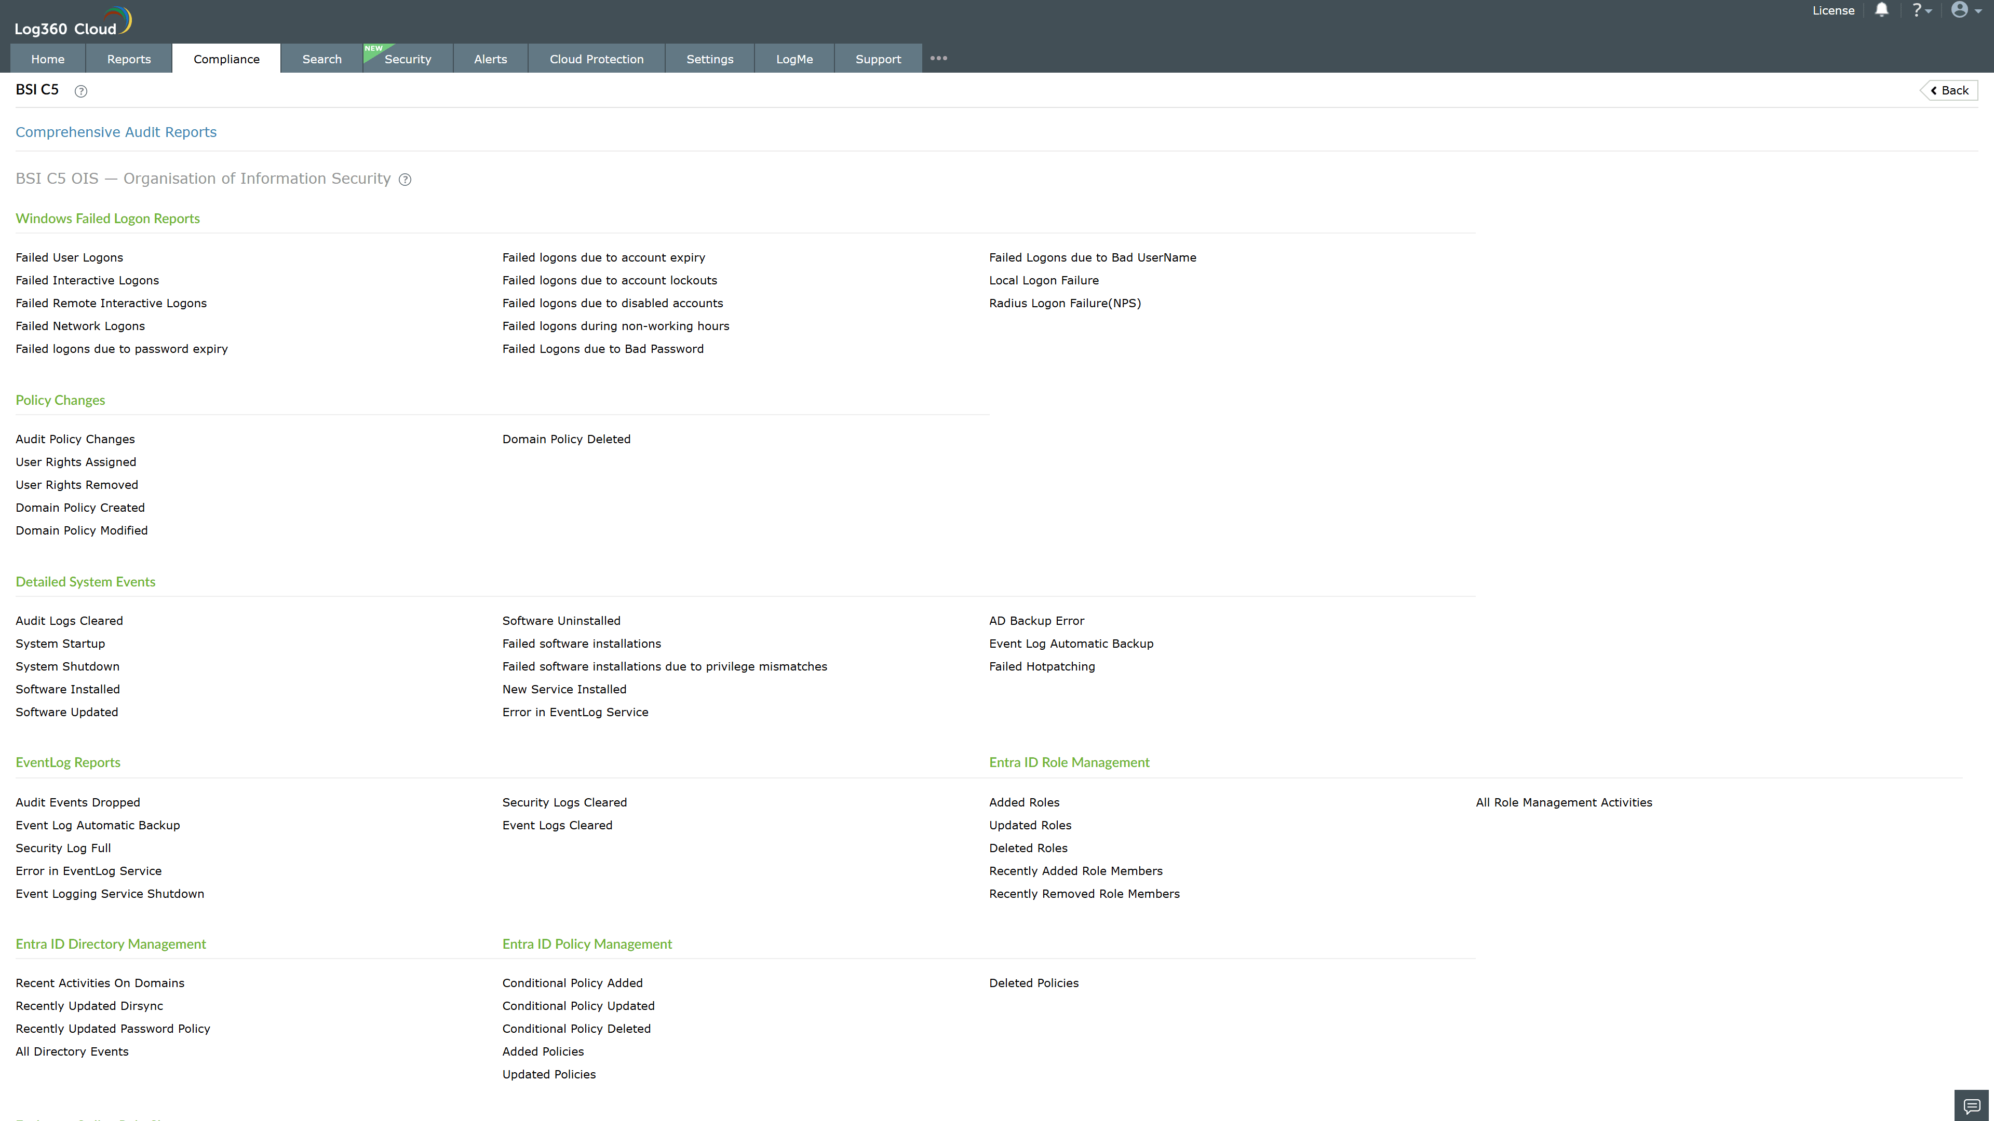
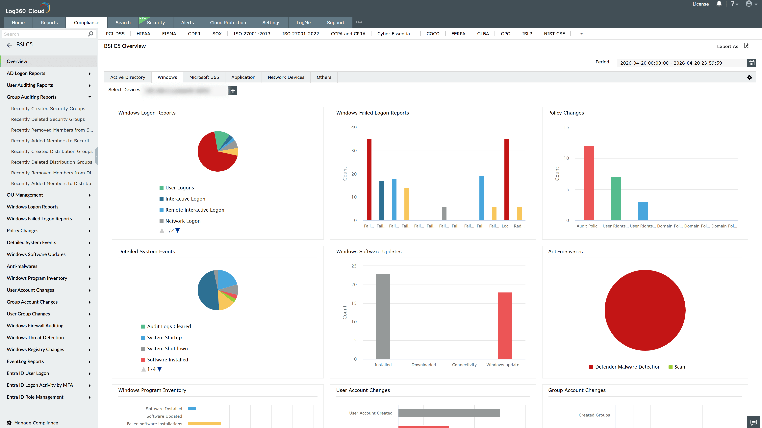
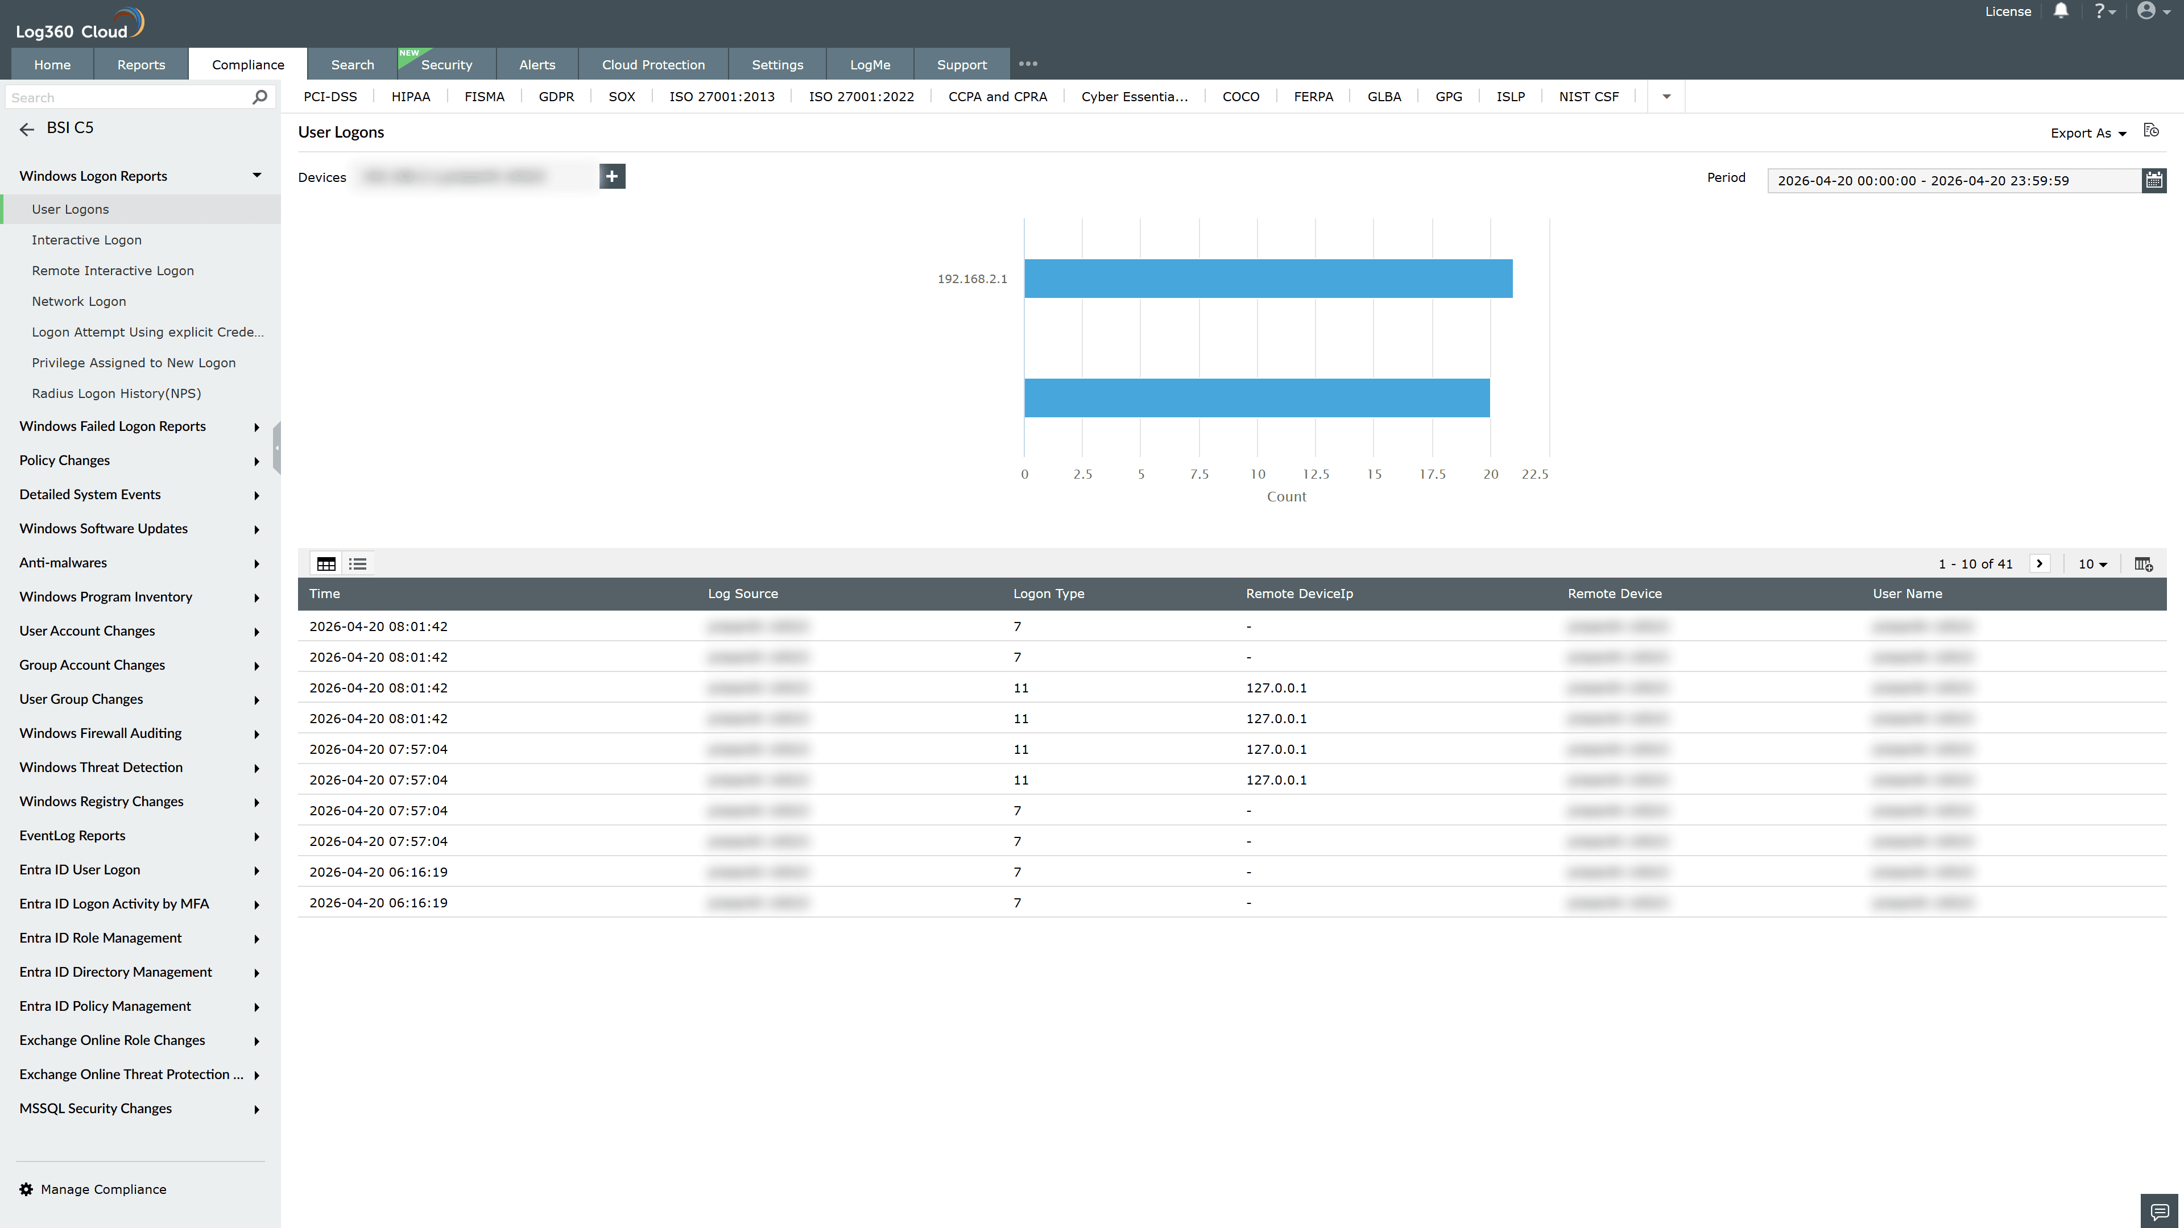
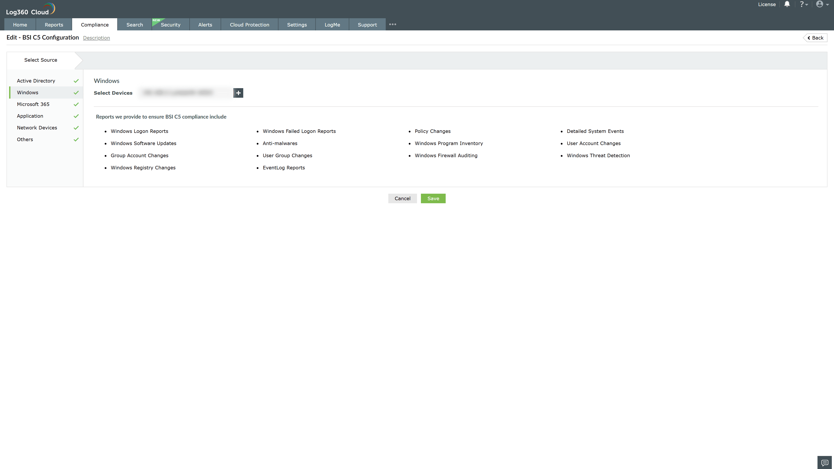
Valid Submission : Yes
Supported Editions : Free, Basic, Standard, Professional, MSSP
Help Document : https://www.manageengine.com/log-management/help/integrations/compliance-extensions.html
Help Video : Not provided
Tags : Log360, Compliance, Privacy monitoring, Data privacy, Regulatory compliance
Supported DCs : US, IN, JP, CA, AU, UK and EU
Privacy Policy:
Terms of Service:
Release Notes:
Predefined reports for the BSI C5 Compliance

